Forecast Salary Growth and Cost of Living - Full Answer

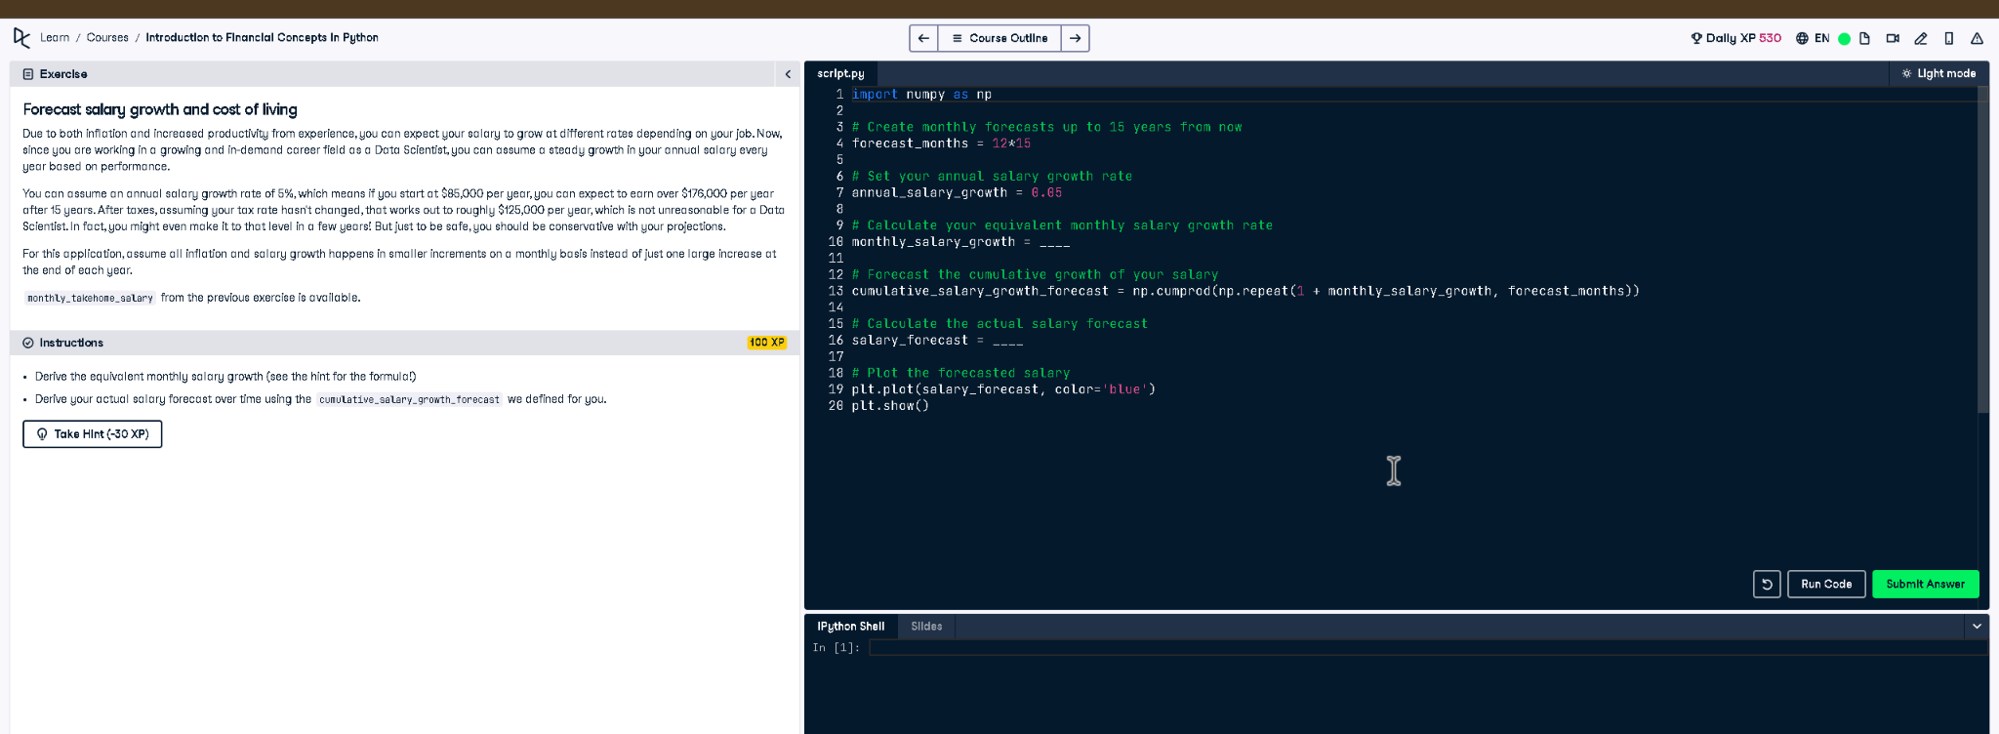

# Full Code Answer:

import numpy as np  
  
# Create monthly forecasts up to 15 years from now  
forecast_months = 12 * 15  
  
# Set your annual salary growth rate  
annual_salary_growth = 0.05  
  
# Calculate your equivalent monthly salary growth rate  
monthly_salary_growth = (1 + annual_salary_growth)**(1/12) - 1  
  
# Forecast the cumulative growth of your salary  
cumulative_salary_growth_forecast = np.cumprod(np.repeat(1 + monthly_salary_growth, forecast_months))  
  
# Calculate the actual salary forecast  
salary_forecast = monthly_takehome_salary * cumulative_salary_growth_forecast  
  
# Plot the forecasted salary  
plt.plot(salary_forecast, color='blue')  
plt.show()

# Question:

How can you forecast monthly salary growth over 15 years using an annual growth rate of 5%?

# 20-word Explanation (Question):

Annual salary growth must be converted into monthly increments to accurately project salaries over multiple years with compounding growth.

# Answer:

Convert annual growth to monthly via (1 + annual)^(1/12) - 1, then apply cumulative np.cumprod for salary.

# 20-word Explanation (Answer):

Using np.cumprod on the monthly growth factor generates a cumulative forecast, scaled by current salary to predict future earnings.